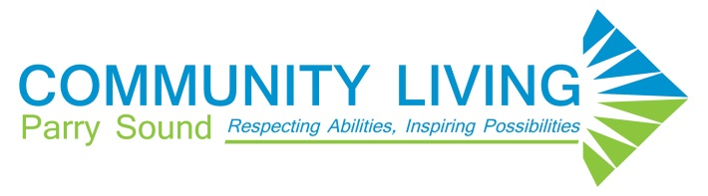

COMMUNITY INCLUSION FUND

Community Inclusion Means:
Presence:
Participating in all settings where people with and without disabilities are present, including classrooms, board rooms, businesses, neighbourhoods, and community events.
Choice:
Having multiple experiences to draw from, selecting and engaging in activities as desired, choosing who will participate with you.
Competence:
Being recognized for strengths, contributing, having opportunities to learn more.
Respect and Valued Roles:
Having every opportunity to participate in community life and being valued for uniqueness and abilities, just like everyone else.
Participation:
Engaging with others, having a wide variety of relationships being known and knowing others, being part of the event.
Belonging:
A very strong feeling that a person experiences when they are valued by others.

Community Inclusion is a Success When People:
- Have relationships with people who are not paid to spend time with them.
- Have opportunities to experience a variety of social roles that include friendships, contributing to the community and gaining new skills.
- Have opportunities and resources to do and accomplish things that are important to them.
- Experience a sense of belonging.

Community Inclusion Fund Committee
The Community Inclusion Fund Committee reviews all requests electronically via email. Applications are submitted to the Manager of Quality Assurance, who without using identifying information, shares the reason for the request and the amount of the request.
The committee responds with their recommendation and using a majority rule process. Decisions are responded to within five business days.

Examples of what the committee will fund:
- Joining a club or team/league such as a bowling team or health club membership
- Taking a course at local college

Examples of what the committee will not fund:
- Activities within CLPS
- Conferences
- Activities outside of the community (unless there is a connection to community; for example, joining a bus trip to go to baseball game or casino with other community members)

